HTML Project

Online Food Ordering System

FINAL - REPORT

**Section – K19TS**

Made By: - Shashank (RK19TSB53)

Rohan Pandey (RK19TSB54)

Gurram Nithin Noyal (RK19TSB55)

Molli Hemanth Syam Siddardha (RK19TSB56)

**Introduction to Online Food Ordering System**

In today’s age of fast food and take-out, many restaurants have chosen to focus on quick preparation and speedy delivery of orders rather than offering a rich dining experience. Until very recently, all of these delivery orders were placed over the phone, but there are many disadvantages to this system. First, the customer must have a physical copy of the restaurant’s menu to look at while placing their order and this menu must be up to date. While this expectation is not unreasonable, it is certainly inconvenient.

Second, the orders are placed using strictly oral communication, which makes it far more difficult for the customer to receive immediate feedback on the order they have placed. This often leads to confusion and incorrect orders. The current system is also inconvenient for the restaurant itself, as they must either have a dedicated staff member to answer the phone and take orders, or some employees must perform double-duty, distracting them from their regular tasks.

What I propose is an online ordering system, originally designed for use in college cafeterias, but just as applicable in any food delivery industry. The main advantage of my system is that it greatly simplifies the ordering process for both the customer and the restaurant. When the customer visits the ordering webpage, they are presented with an interactive and up-to-date menu, complete with all available options and dynamically adjusting prices based on the selected options. After making a selection, the item is then added to their order, which the customer can review the details of at any time before checking out. This provides instant visual confirmation of what was selected and ensures that items in the order are, in fact, what was intended.

The system also greatly lightens the load on the restaurant’s end, as the entire process of taking orders is automated. Once an order is placed on the webpage, it is placed into the database and then retrieved, in pretty much real-time, by a desktop application on the restaurant’s end. Within this application, all items in the order are displayed, along with their corresponding options and delivery details, in a concise and easy to read manner. This allows restaurant employees to quickly go through the orders as they are placed and produce the necessary items with minimal delay and confusion.

While there are already a few systems like this in existence, all those I have encountered have been designed specifically for one restaurant, and thus cater only to their unique needs. Perhaps the greatest advantage of my system is its flexibility. The web order forms are built dynamically from the database, which can be managed using a graphical user interface. This allows the restaurant employees to not only set up and customize the system on their own, but also allows them to make changes to the menu in real time. For this reason, the exact same system can be used by numerous businesses with absolutely no modification to the code itself, which greatly increases its usefulness.

**Functionalities:-**

* Provides the searching facilities based on various factors. Such as Food, Shopping Cart, Customer and Order.
* Online Food Ordering System also manage the Delivery Address details online for Customer Details and Food.
* It tracks all the information of Item Category, Delivery Address, and Customer etc.
* Manages the information of Item Category.
* Shows the information and description of the Food and Item Category.
* It deals with monitoring the information and transactions of Customer.

Editing, Adding and Updating of records is improved which results in proper resource management of Food Data.

**Modules:-**

1. Introduction Module (By Shashank): - Introduction page is used to attract people to order food from our site rather than ordering from competitive online ordering site.
2. Login Module (By Rohan Panday): - Logins are used by [websites](https://techterms.com/definition/website), computer [applications](https://techterms.com/definition/application), and mobile [apps](https://techterms.com/definition/app). They are a security measure designed to prevent unauthorized access to confidential [data](https://techterms.com/definition/data). When a login fails (i.e., the username and password combination does not match a user account), the user is disallowed access.

There will be two ways to login. Number 1 is from Customer side and Number 2 is from Admin side.

1. Admin Logged-in Module(Rohan Panday): - This will take us to the pages from where admin can keep an eye on all the sales, profit and customer percentage.
2. User Logged-in Module: - This will take us to the pages from where customer can see the list of food and add the food to the cart and can do the payment for the foods.

1. Restaurants List Module (By Shashank): - This page will show the list of all the restaurants which are available in his/her area after filling the address of the delivery location. This page will also show the all ongoing discounts, coupons and top food brands which is according the Gantt chart.
2. Restaurant Food List Module (By Shashank): - This page will show the list of all food available in a particular restaurant. From here the customer can add the food to the cart.
3. Confirmation Module (By Syam): - This page will show the confirmation for the payment mode whether go with Cash on Delivery or go with online payment.
4. Online Payment module (By Syam): - This page will show the process for the payment either from credit/debit card.
5. Thank You module (By Nithin): - This page will finalise the order by thanking customer and will tell the customer if he/she want to order can order by going on home screen.
6. Contact Us module (By Rohan Panday): - This page will provide the full address of the office of the website and will also provide phone numbers for any complaints.
7. About Us module (By Rohan Panday): - This page will provide all the information about the idea behind this website and history behind the making of the website.
8. Terms & Conditions module (By Nithin): - This page will provide all the Terms & Conditions that needs to be followed while using the website.

**Structure:-**

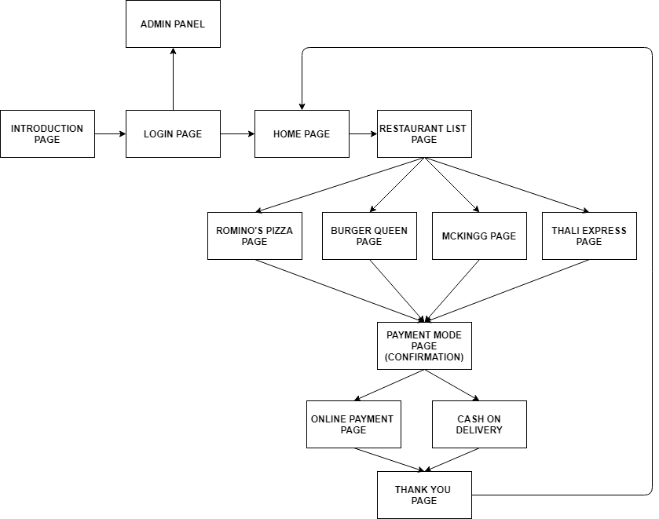

**How this Works:-**

1. Starts from Introduction page where customer will provide address where customer wants the order to be delivered and customer will be able to login to his/her account by clicking “Find Food” button or by clicking “Login” button.

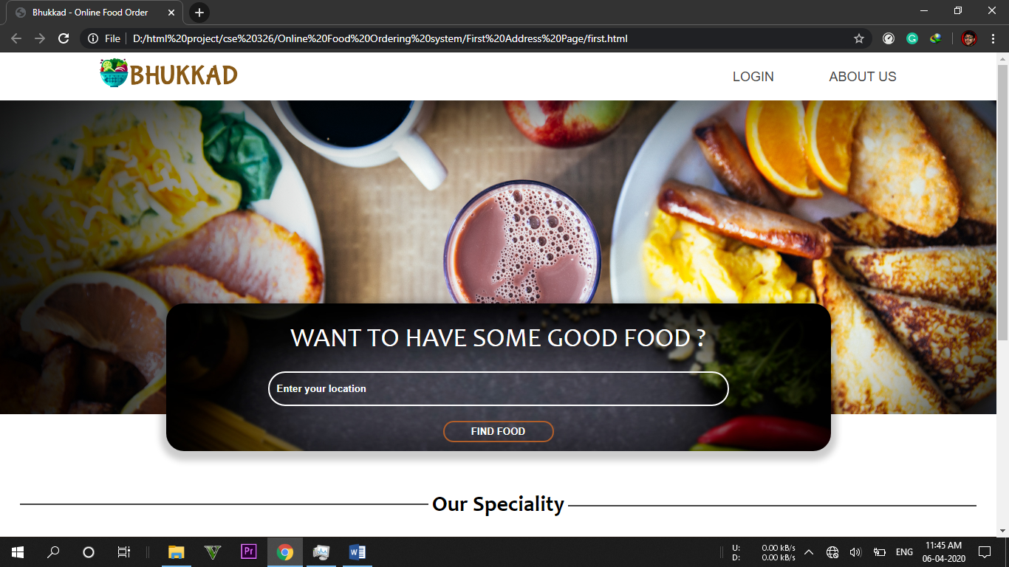

Three links are provided at the bottom: - About Us, Contact Us and Terms & Conditions.

1. About Us.

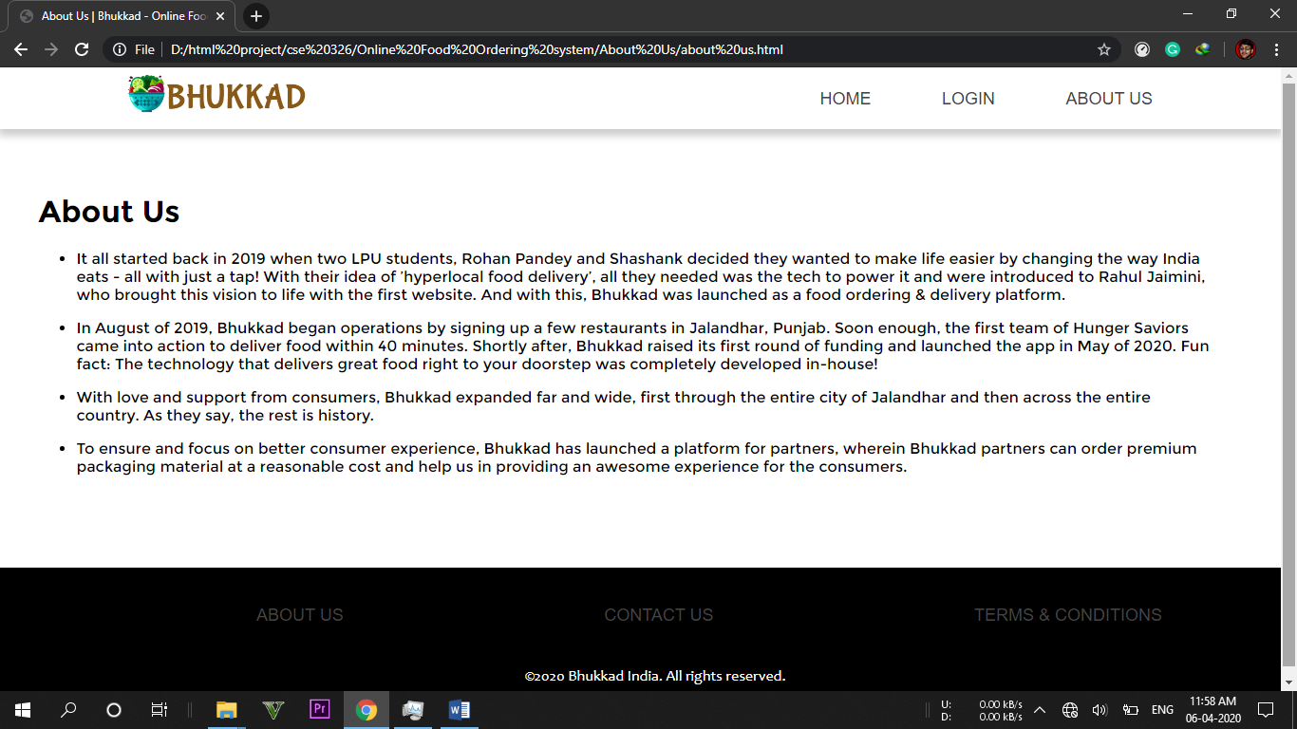

1. Contact Us.

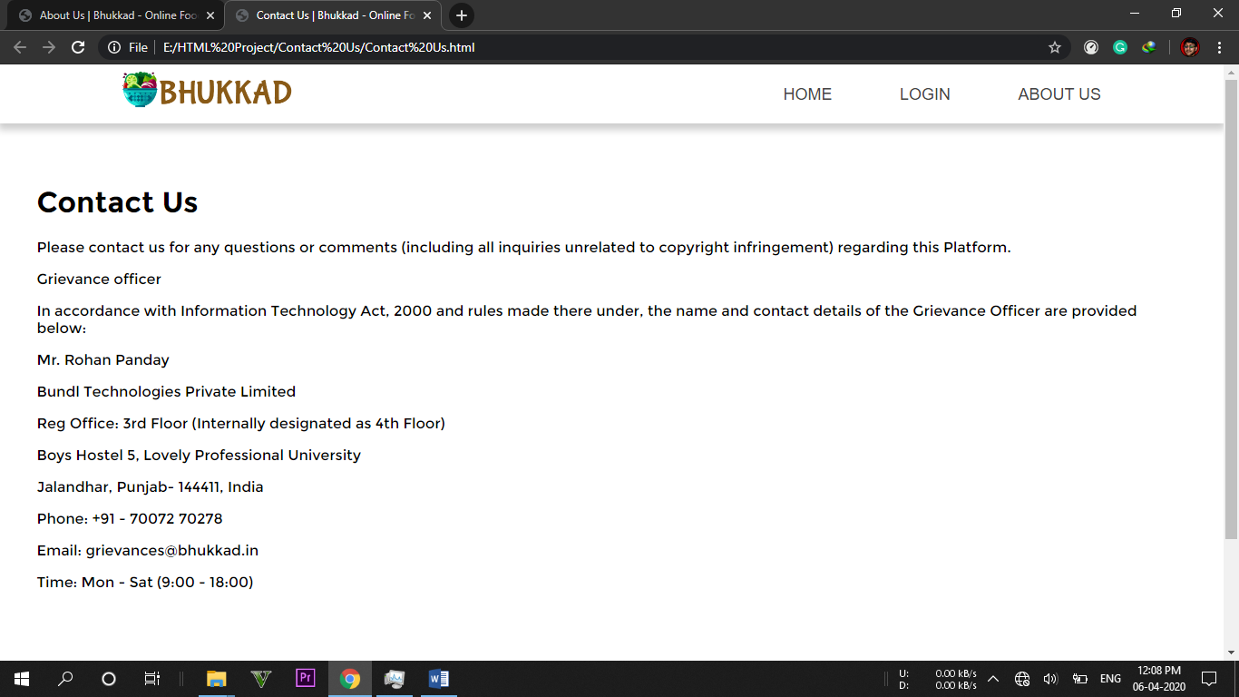

1. Terms & Conditions

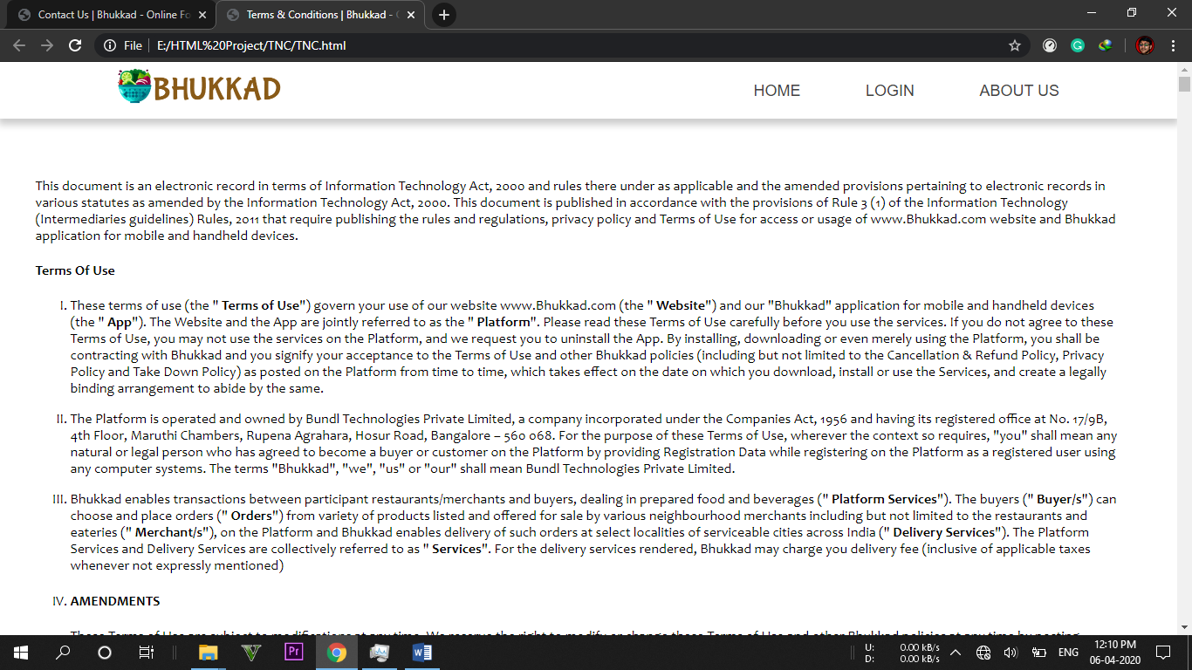

1. Login Page

There will be two ways to login. Number 1 is from Customer side and Number 2 is from Admin side. For buttons in CSS, HOVER is used to change the colour of the button when mouse hovers over the buttons. For text fields in CSS, FOCUS is used to change the width and border colour of the text field.

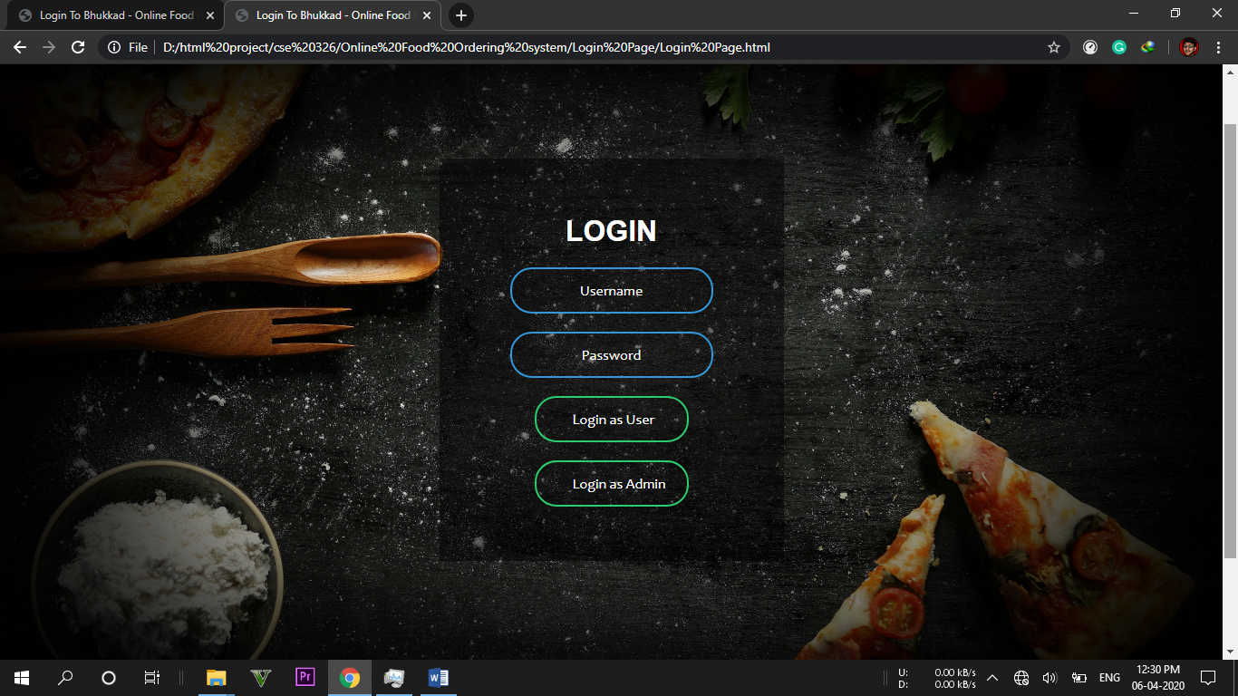

1. Home Page

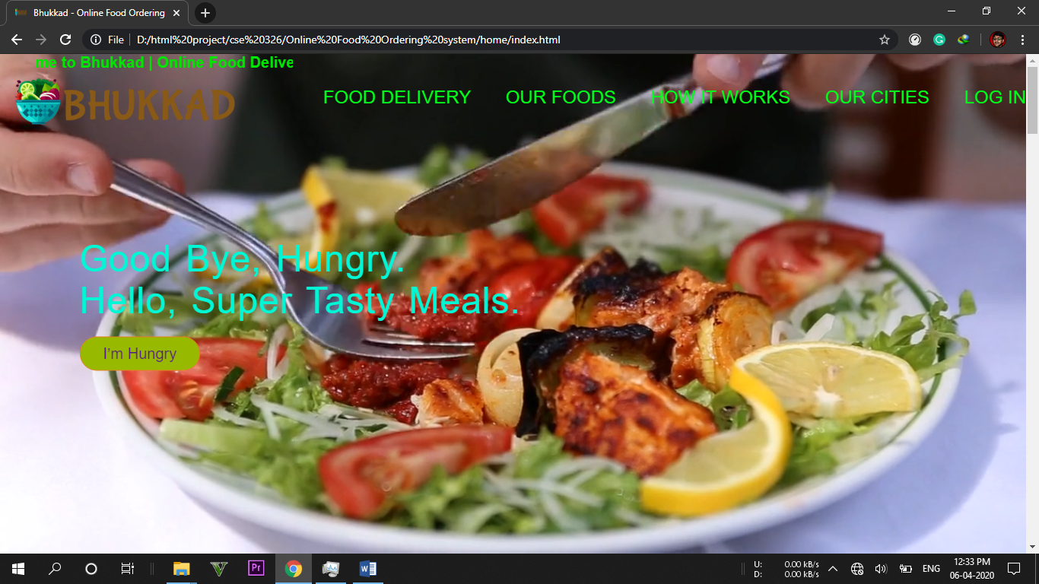

This page provides all the information about the website. By clicking “I’m Hungry” Button the page is directed to all the available Restaurants.

1. Restaurant List Page

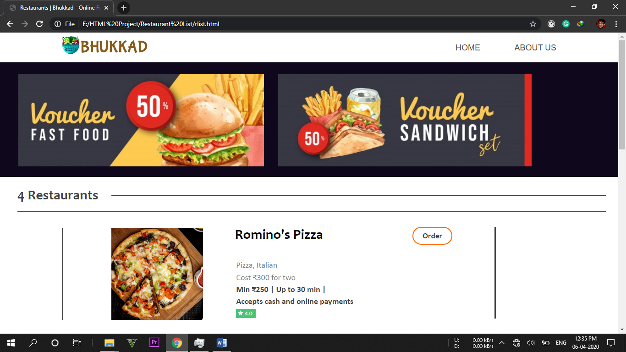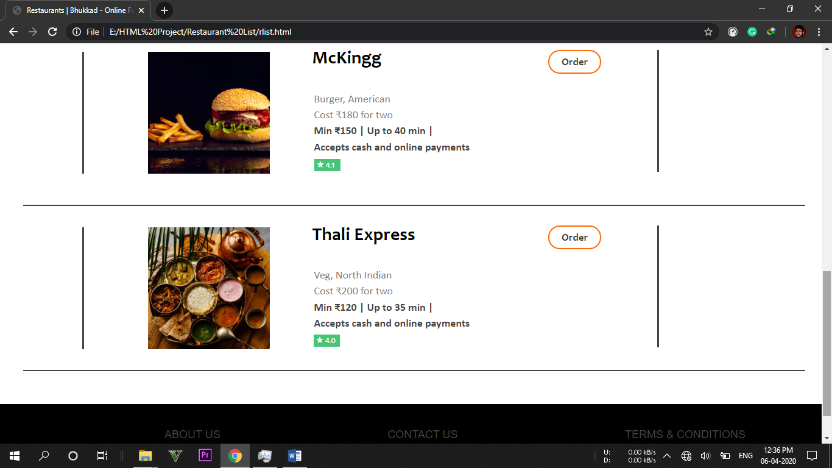

There are total 4 restaurants available and each restaurant contains 8 varieties of food available and “Order” button will direct to the particular restaurant menu.

1. Restaurant Food List

There are 8 varieties of food available in each restaurant page and clicking “Price Tag” it will direct to the confirmation page.

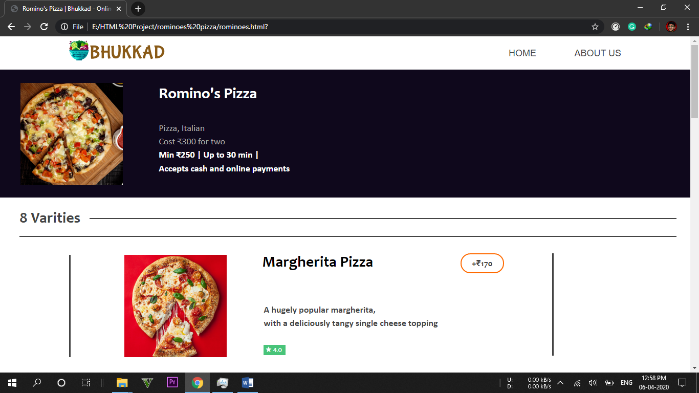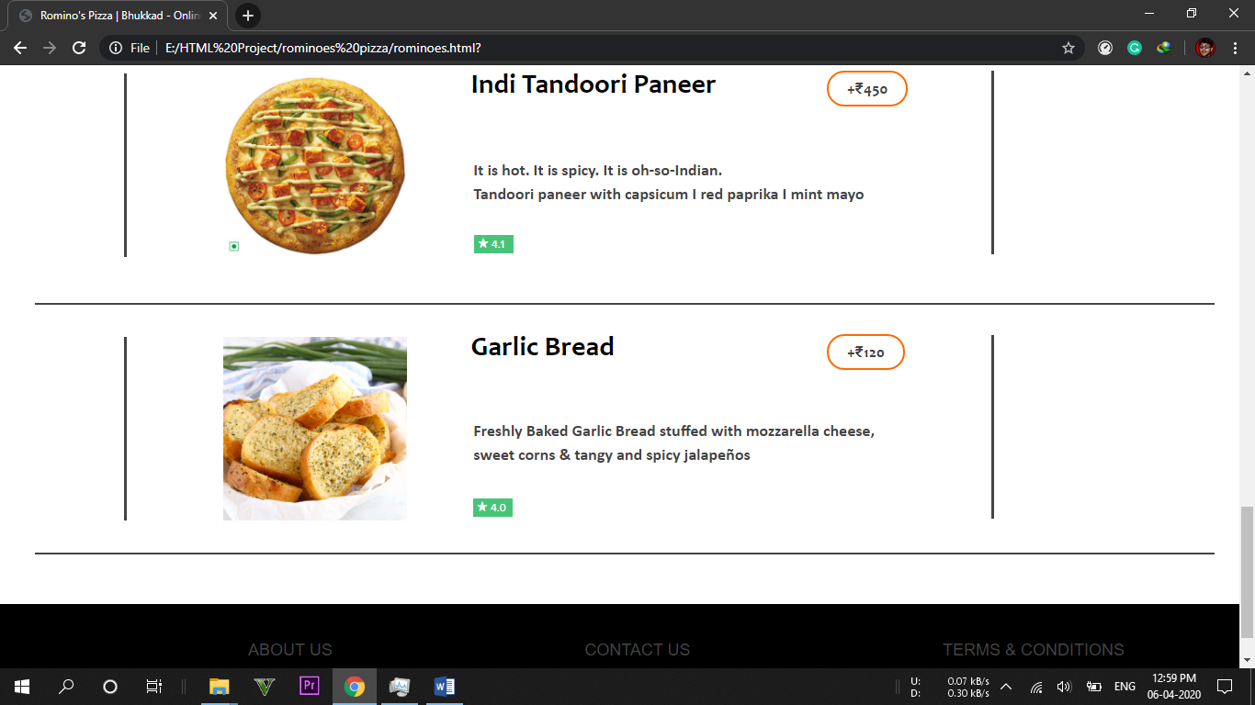

1. Payment Mode (Confirmation)

This page will give 2 options for the payments: - Cash On Delivery and Online Payment. Cash on Delivery will confirm the order. Online payment will direct to the online payment page.

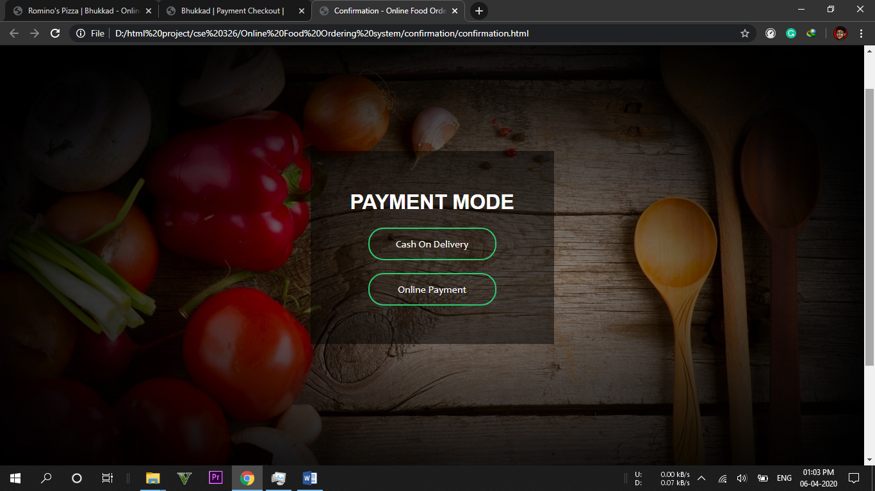

1. Online Payment page

This page will allow customer to fill the card details for the online payment. After that order will be confirmed.

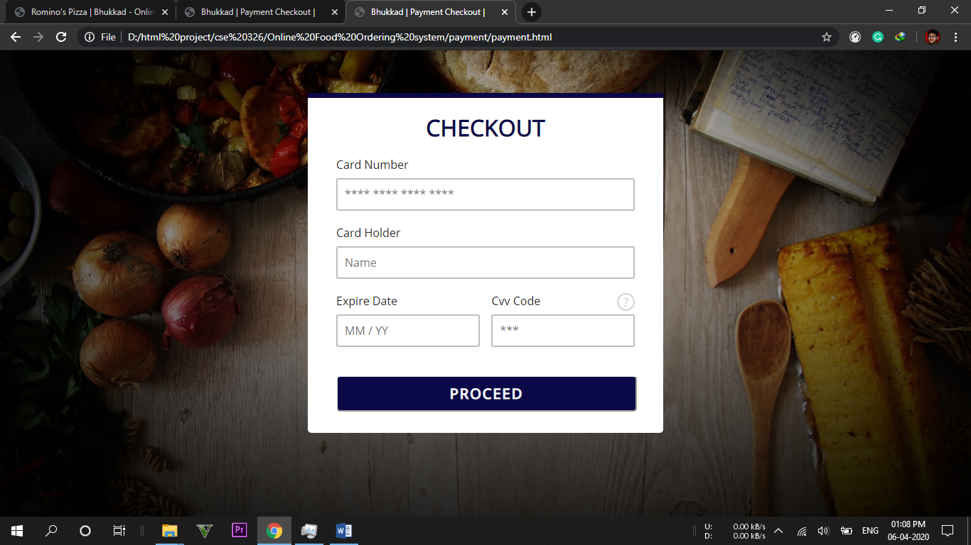

1. Thank You Page

This page will confirm the order and will allow the customer that he/she can return to the home page to order more.

